**Test Case** **0047**

**System:** VirtuCardsClient

**Description:** Test to ensure that a client’s Avatar choice is reflected on other devices.

**Severity:** 3

**Instructions**

**Test 1**

1. Start VirtuCardClient application
2. Click the button labeled “Sign In”
3. Enter “test@test0.com” into the text input labeled “Enter email…”
4. Enter “Password!123” into the text input labeled “Enter password…”
5. Press the button labeled “Login”
6. A window should appear saying “Login Success”
7. Press the OK button that appears on that window
8. Click the Profile icon located in the top left of the screen.
9. Click the button labeled “Edit Avatar”
10. Click the button labeled “Upload Custom”
11. Select an image from the device as the new Avatar.
12. Close the application
13. Start another instance of the VirtuCardClient application on another device
14. Repeat Steps 1-8.

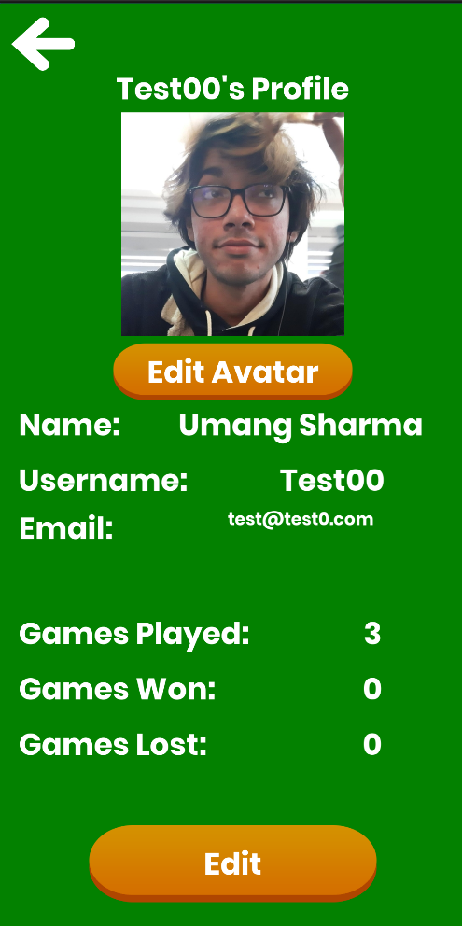**Expected Result:** The profile page should show the chosen image as the Avatar after restarting the application.

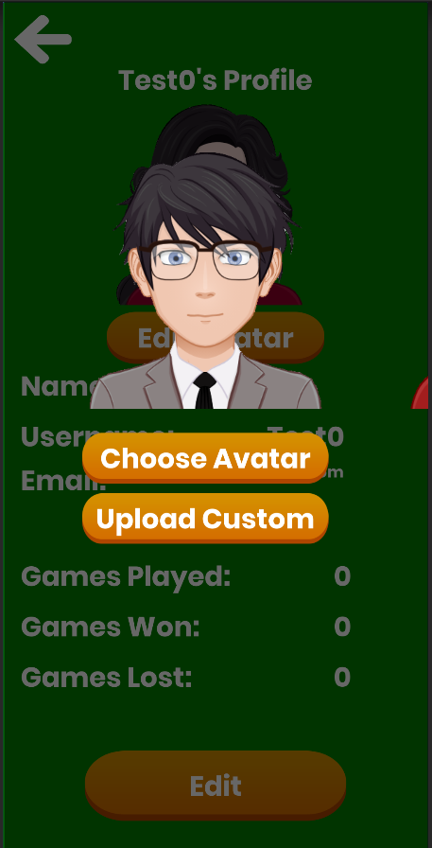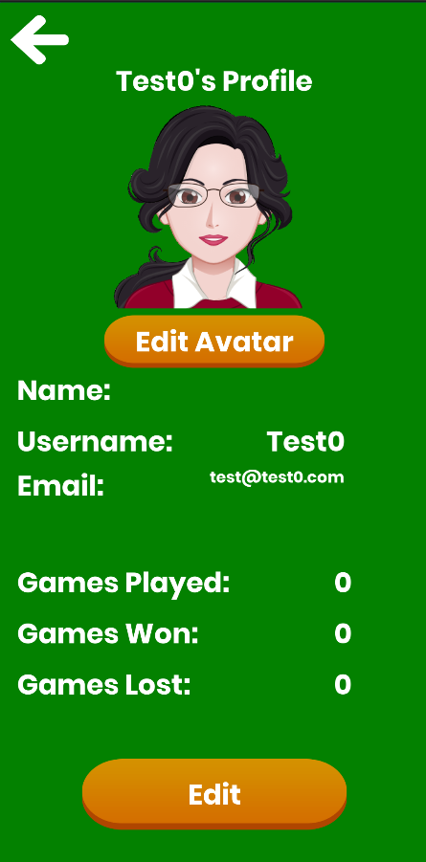

The new Avatar should be shown now above the Edit Avatar button.

Click the button labeled Upload Custom and choose an image from the device as the new Avatar.

Click the Edit Avatar button on the Profile screen to change the avatar.

****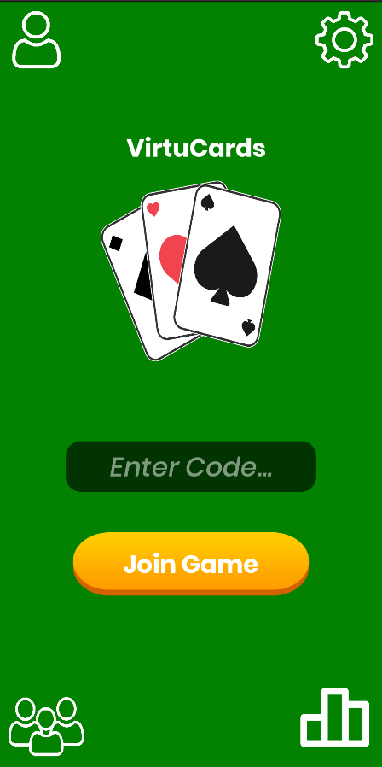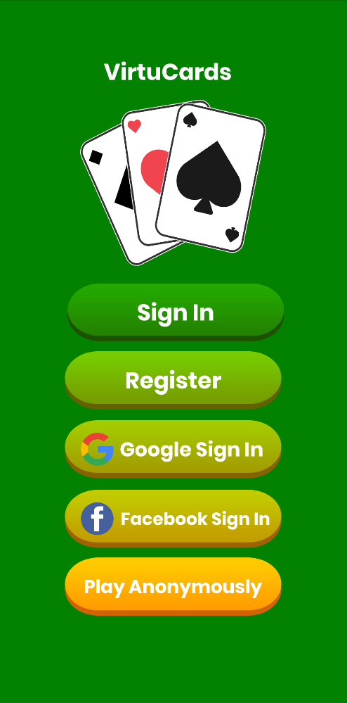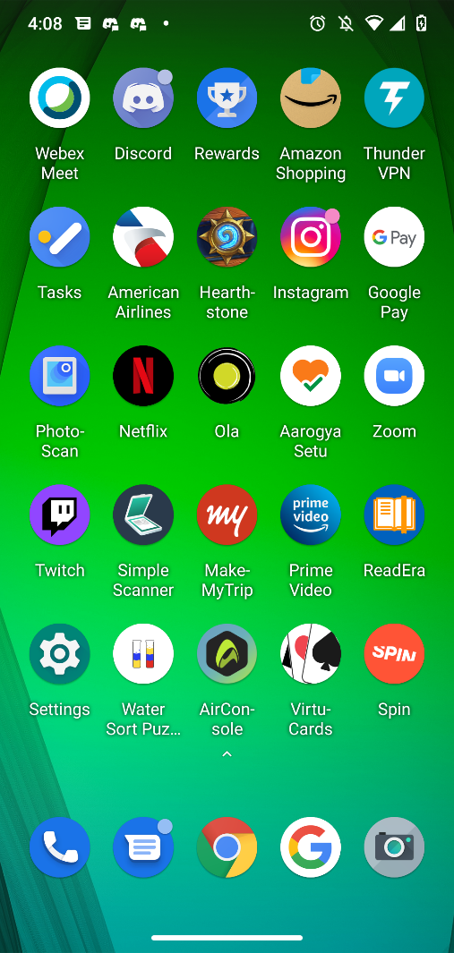

The Profile Screen should display the chosen Avatar now.

Click the Profile Icon in the top left screen.

Restart the VirtuCardsClient application on another device, and sign-in using the credentials mentioned above.

Close the VirtuCards application.

**Test 2**

1. Start VirtuCardClient application
2. Click the button labeled “Google Sign In”
3. Choose a Google account you would like to sign-in with.
4. Click the Profile icon located in the top left of the screen.
5. Click the button labeled “Edit Avatar”
6. Click the button labeled “Upload Custom”
7. Select an image from the device as the new Avatar.
8. Close the application
9. Start another instance of the VirtuCardClient application on another device
10. Repeat Steps 1-4.

**Expected Result:** The profile page should show the chosen image as the Avatar

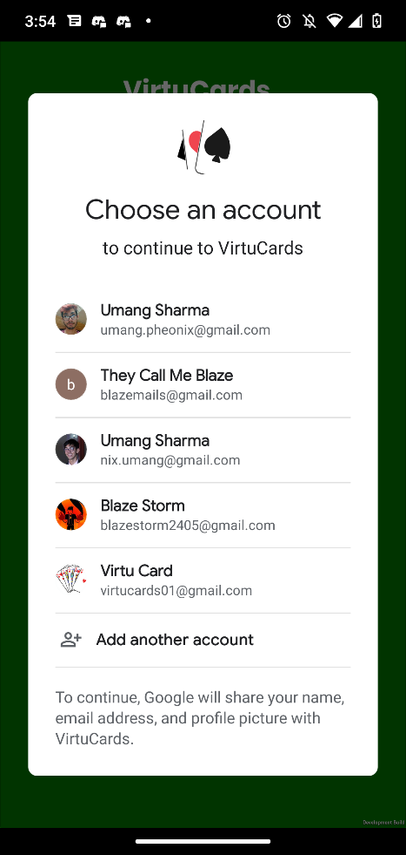

The Join Code screen will load after the user chooses their desired Google account. Click the Profile Screen icon in the top left.

The above image displays the screen after the user presses the Google Sign in button. Choose your desired account from the ones displayed on your screen. The accounts above are examples

The above image displays the landing page. The Google Sign in button is highlighted as this is the sign-in method used in this test.



********

The above image displays the Profile Screen. Click the Edit Avatar button.

The Expected Result is that the chosen Avatar is shown above the Edit Avatar button now.

Click the button labeled Upload Custom and choose an image from the device as the new Avatar.

The Profile Screen should display the chosen Avatar now.

Click the Profile Icon in the top left screen.

Restart the VirtuCardsClient application on another device, and sign-in using the credentials mentioned above.

Close the VirtuCards application.

**Test 3**

1. Start VirtuCardClient application
2. Click the button labeled “Sign In”
3. Enter “test@test0.com” into the text input labeled “Enter email…”
4. Enter “Password!123” into the text input labeled “Enter password…”
5. Press the button labeled “Login”
6. A window should appear saying “Login Success”
7. Press the OK button that appears on that window
8. Click the Profile icon located in the top left of the screen.
9. Click the button labeled “Edit Avatar”
10. Select a preset Avatar by swiping and clicking Choose Avatar.
11. Close the application
12. Start another instance of the VirtuCardClient application on another device.
13. Repeat Steps 1-8.

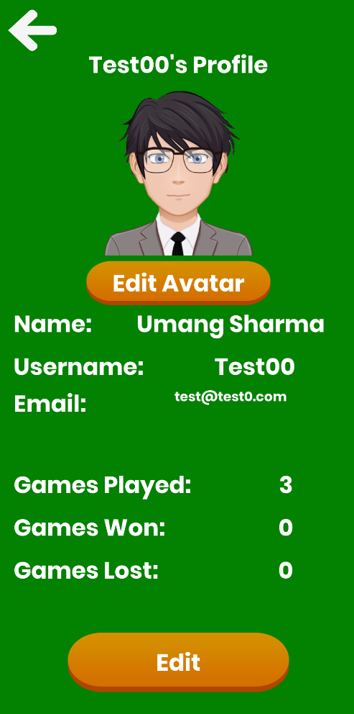**Expected Result:** The profile page should show the chosen image as the Avatar after restarting the application.



The new Avatar should be shown now above the Edit Avatar button.

Click the button labeled Upload Custom and choose an image from the device as the new Avatar.

Click the Edit Avatar button on the Profile screen to change the avatar.

********

The Profile Screen should display the chosen Avatar now.

Click the Profile Icon in the top left screen.

Restart the VirtuCardsClient application, and sign-in using the credentials mentioned above.

Close the VirtuCards application.

**Test 4**

1. Start VirtuCardClient application
2. Click the button labeled “Google Sign In”
3. Choose a Google account you would like to sign in with.
4. A window should appear saying “Login Success”
5. Press the OK button that appears on that window
6. Click the Profile icon located in the top left of the screen.
7. Click the button labeled “Edit Avatar”
8. Select an Avatar from the presets by swiping and clicking Choose Avatar.
9. Close the application
10. Start another instance of the VirtuCardClient application
11. Repeat Steps 1-6.

**Expected Result:** The profile page should show the chosen image as the Avatar after restarting the application.



Click the profile icon in the top left of the screen.

Choose your desired Google account.

Click the Google Sign In button on the landing page.

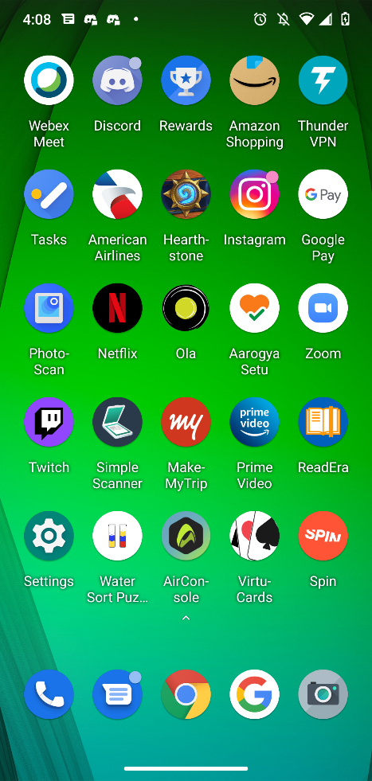

Click the profile icon in the top left of the screen.

Restart the application and click the Google Sign In button.

Close the application.

The chosen avatar should now be displayed on the profile screen.

Click the button labeled Upload Custom and choose an image from the device as the new Avatar.

Click the Edit Avatar button.



The chosen Avatar should be displayed in the profile screen still.